What A Relief! Massage Therapy Center, Inc

NAME________________________________________________________________________BIRTH DATE_______________________________
ADDRESS____________________________________________CITY___________________________STATE______ZIP__________________
PHONE CONTACT: _____________________________________EMAIL:_________________________________________________________
HOW YOU HEARD ABOUT US: _______________________________________ OCCUPATION: ______________________________________
PRIMARY REASON FOR THIS VISIT:____________________________________________________________________________________
_________________________________________________________HOW LONG YOU’VE HAD THIS PROBLEM: _______________________
PRIMARY CARE PHYSICIAN:_______________________________________________PHONE:______________________________________
YOUR CHIROPRACTOR: __________________________________________________PHONE:______________________________________
ALLERGIES? 1.________________________________2.________________________________3.____________________________________
PREFERRED PRESSURE? [ EASY ] [ MEDIUM ] [ HARD ] COMFORTABLE LAYING ON BELLY? ________ PREGNANT? __________
BRUISES, BURNS, CUTS, BROKEN BONES, OR INCISIONS? _________________________________________________________________
PLEASE DESCRIBE ANY SKIN CONDITION OR COMMUNICABLE ILLNESS (or tell therapist before the session begins) ____________________________________________________________________________________________________________________
ANY QUESTIONS ABOUT YOUR MASSAGE SESSION?____________________________________________________________________
____________________________________________________________________________________________________________________
WHAT GOALS DO YOU HAVE FOR YOUR BODY? 1._____________________________________________________________________
2.______________________________________________________3.___________________________________________________________

CONSENT TO RECEIVE MASSAGE THERAPY:
The available therapist has my permission to administer various massage therapy techniques for the purpose of relieving pain and stress, and for maximizing muscular performance. I agree to inform the therapist of any changes in my health condition while being serviced at this business, and to communicate with him/her if I feel compromised physically or mentally at any time during the massage.
Signature _________________________________________ Date ___________________________

PRIVACY STATEMENT
Any and all of the personal information you provide is only for the use of What A Relief! Massage Therapy Center, Inc. and will be held in the strictest confidence for use in providing you with the best massages and pain relief possible. Your information will not be shared with any other agency, business, or mailing list without your approval in writing.
Signature_________________________________________ Date___________________________

CANCELLATION POLICY
An appointment constitutes an agreement between What A Relief! Massage Therapy Center, Inc.
and the client. What A Relief! will perform the desired therapy and the client will be present for the requested therapy. In the event the client cannot be present for the appointment, we require 24 hours cancellation notice except in the event of a sudden illness or an emergency. The client will be charged for a missed appointment. Reminders are a courtesy only, we want to help our clients reach their appointments for their benefit.
Initial here: _____________
EMAIL NEWSLETTER
I would like to receive your periodic email newsletters. Initial here: _____________

Lifestyle Questions:
Hours of sleep?_____ Water intake per day? (bottles) _________ Breathing? ________ Stretching? __________
Primary exercise type?___________________________ Frequency of Exercise?__________________________
Self-massage?_______________ massage?________________ Diet? (healthy) (fairly healthy) (unhealthy)

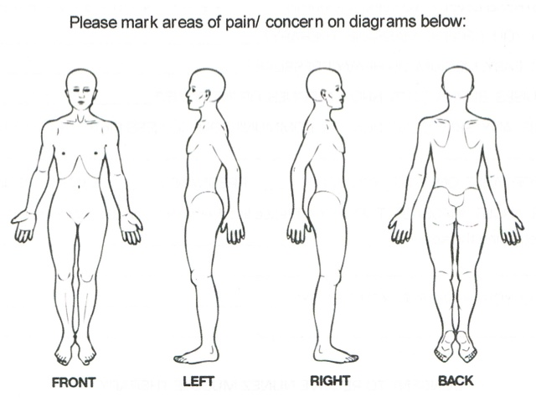

For therapist to complete:
Muscles on the left side:
1._________________________2.____________________________3.____________________________
4.____________________________ 5._____________________________

Muscles on the right side:
1.______________________2.________________________3.___________________________
4.____________________________5._____________________________6._____________________________.

Common postures/movements of the client:
1._________________________________2.__________________________3.______________________________
4._______________________________5._______________________________.

Medical history:
1.____________________________________________________________________________________________
2.____________________________________________________________________________________________
3.____________________________________________________________________________________________
4.____________________________________________________________________________________________

General Observations:
1.____________________________________________________________________________________________
2.____________________________________________________________________________________________
3.____________________________________________________________________________________________
4.____________________________________________________________________________________________

